MIS 6309 – USE CASE REQUIREMENTS

Use Case Name: Predictive Analytics in Tableau

-GROUP 3

# Use Case Description:

This use case explains how we can analyse a dataset and forecast the predictions for the next time frame. The data set that we are using is a Stock Market Analysis. Based on past data about Stock Market prices, we analyse data in tableau and predict the future.

# Learning Objective:

The learning objective of this use case is to practice and learn the analytic works of Tableau. We will be working on the stock market analysis dataset to analyse and predict In tableau.

# Software Requirement (s):

Tableau

# Step by step instruction of completing the use case

1. We need to add the dataset we are using for our purpose in tableau. For this project I am adding prices dataset. It includes the name of stock, acronym used during trading and the following prices list for the stock – open, close, high, low. It also includes a column of date corresponding to every cost of the stock.

In Tableau we have various option to add data for visualisation :- Microsoft Excel for Excel file, Text File for CSV etc.

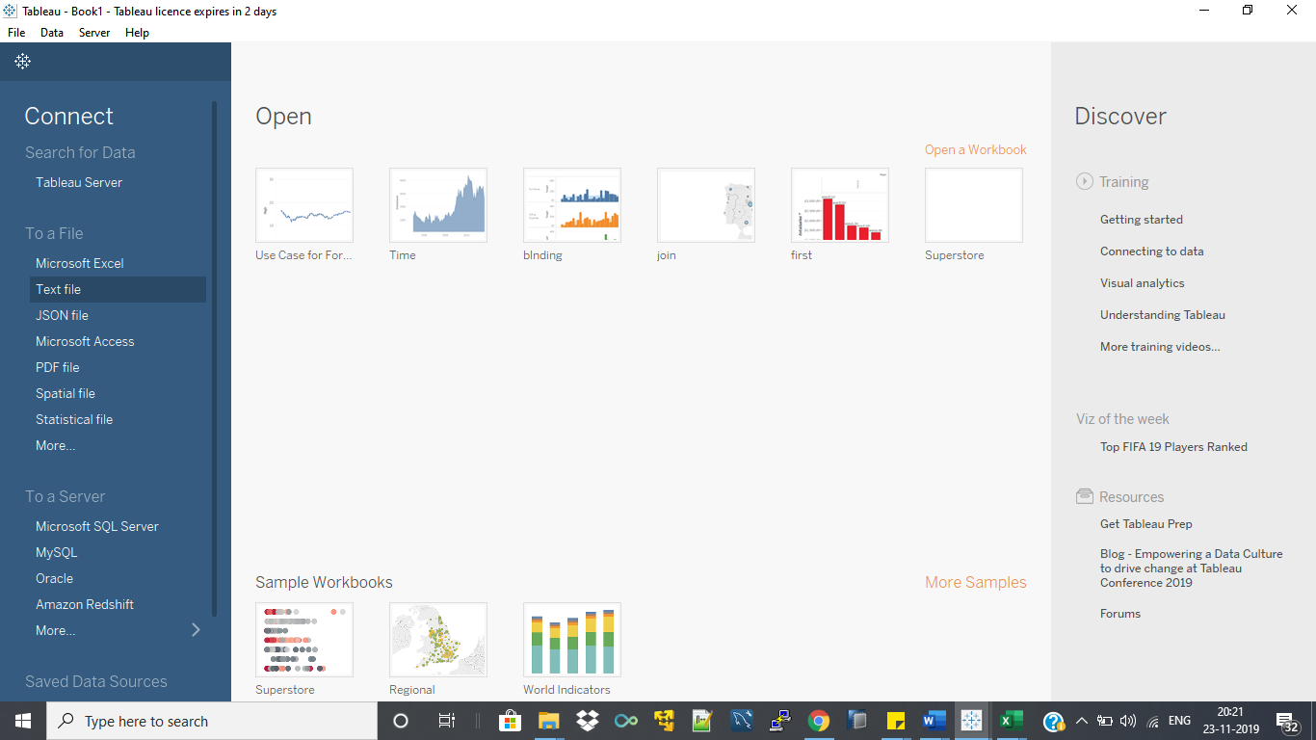

1. After dataset import it look as below, text highlighted in red are the column inside our imported prices file.

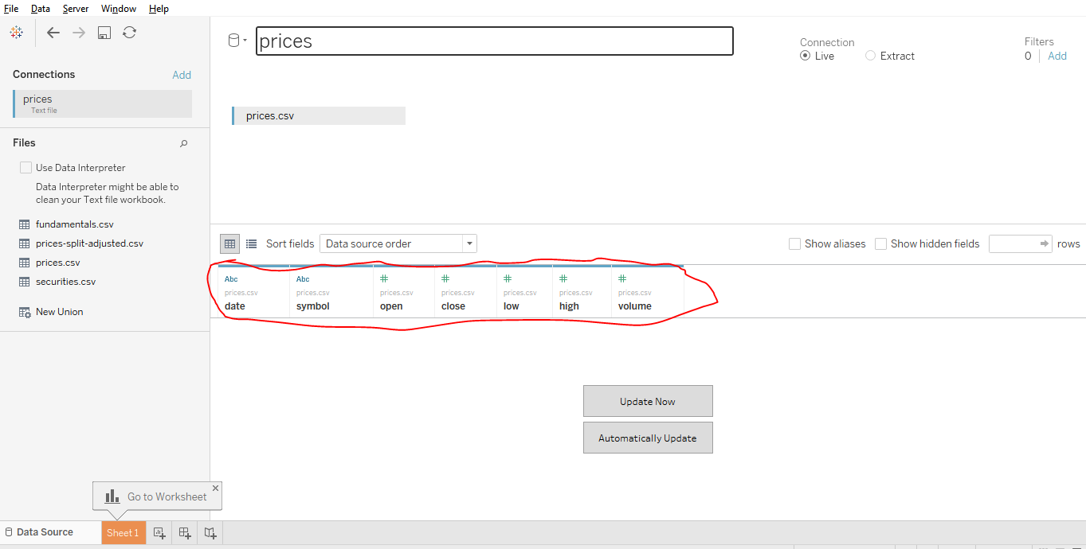

1. After importing our data to tableau to start working on it we need to select the worksheet as in the above picture highlighted in orange colour.

Once we select worksheet it will show various columns of our data set in “dimension” and “measure”. Dimensions are the various aspects of our dataset which are generally not numerical in value and measures are the numerical part of our dataset.

We need to drag the column from dimension and measure side to the middle if we want its effect in our visualization.

I have selected date of stocks for the visualization part and selected the option of aggregation based on month as below :-

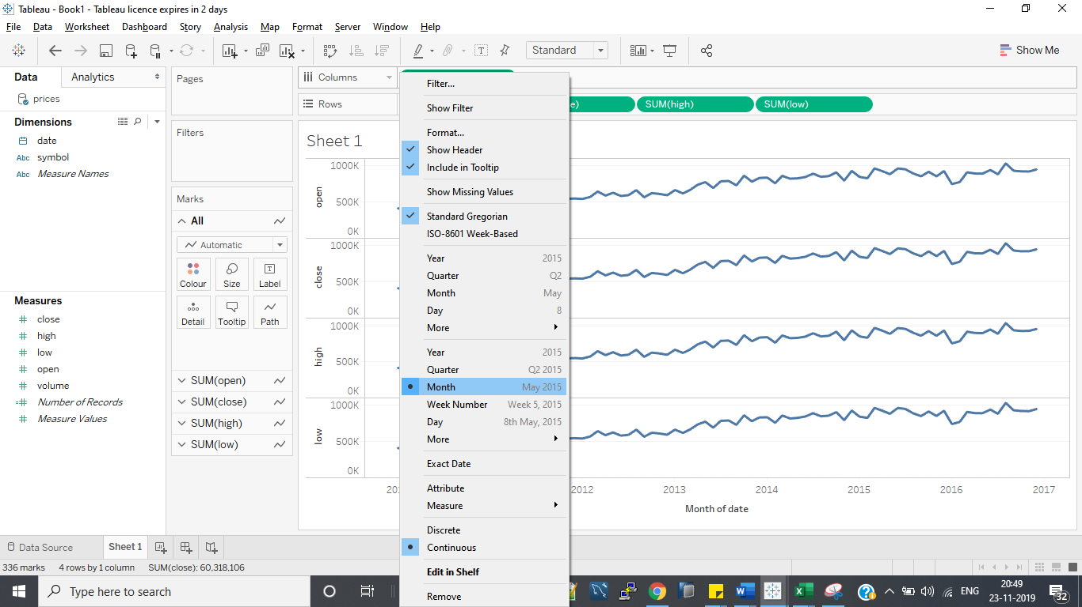

1. Now a user may need the visualization for opening price, closing price, highest value, lowest value of the stock. Here I have chosen a dataset that include all of these prices. Content highlighted in red are the time period associated with prices shown above.

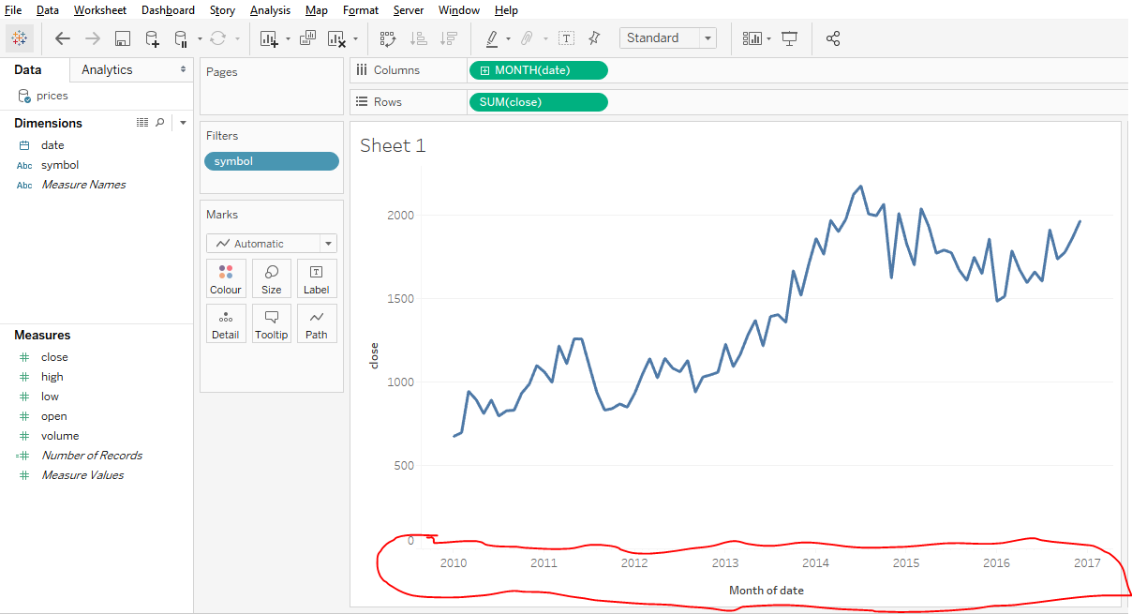

1. Here we can show the visualization in the form of Bar Graph, Circle, Square etc but we have chosen line graph as our preferred option because it is generally preferred as the most understandable option for forecasting. In the below picture it is shown the different visualization shape we can obtain :-

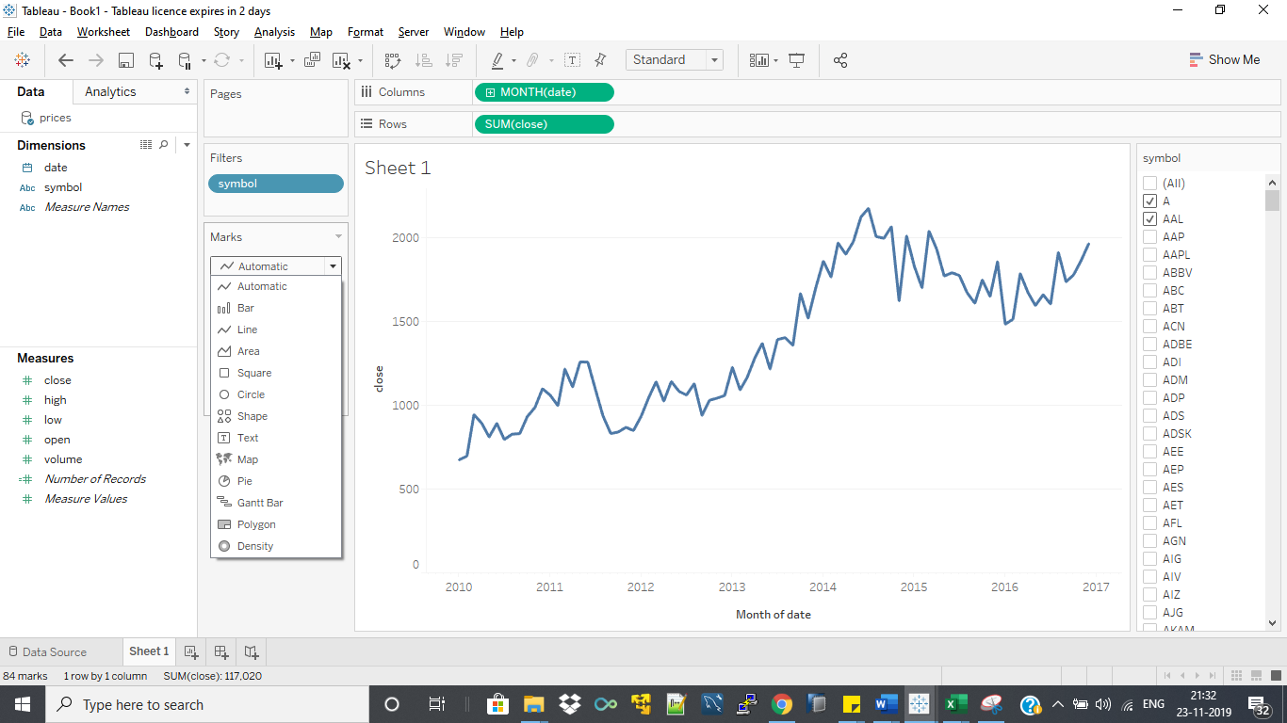

1. Now this can be used by the user interested in various stocks. So I have provided a filter option for the various stocks selection user is interested in. Filter can be created by dragging that column in filter named section and right click will generate the filter selection pop up menu selecting the edit filter option. Symbol list on the right side can be used to select the stocks

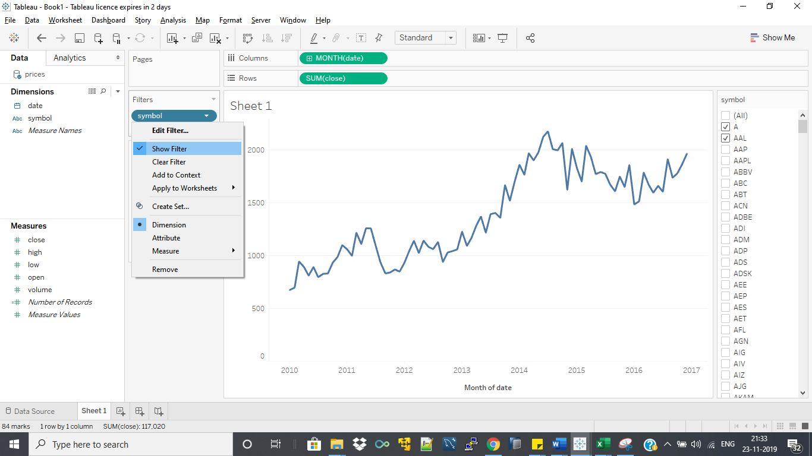

1. User can also be interested in the number of stocks exchanged. I have included that thing also in the visualisation.

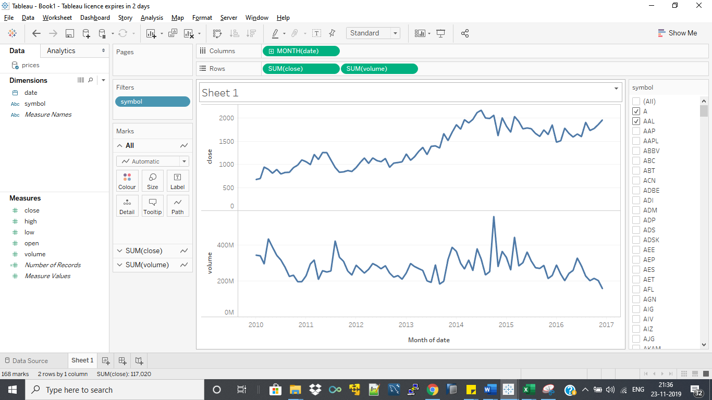

1. Now to show any forecasting we need to do select the following option shown in the below picture:-

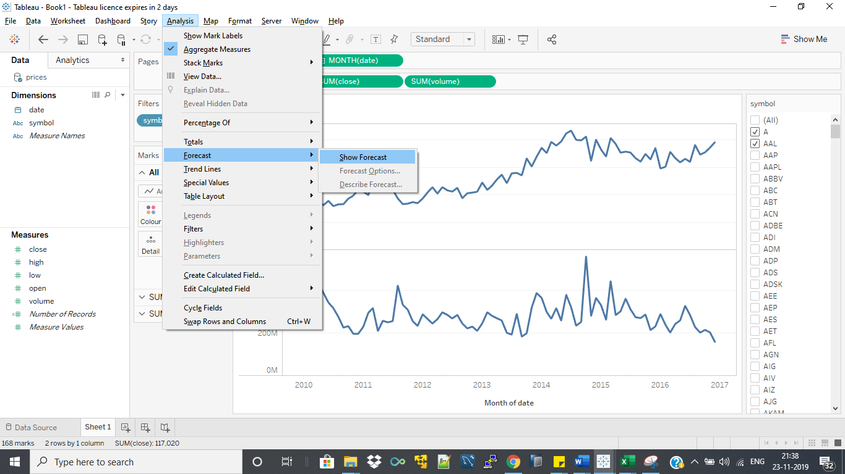

1. After selecting the above option, we get the following graph. Content highlighted in bluish blue is the forecasting. Now it is showing nothing because we have to select some customization for proper forecasting.

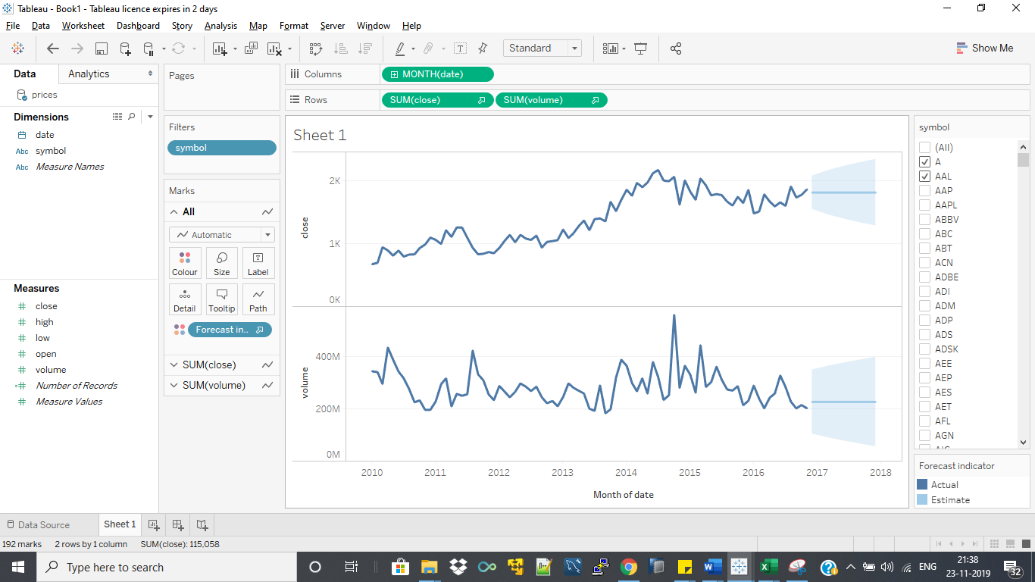

1. Now it is good to read if we provide different colour for actual data representation and forecasted data. We can select this option by double click on the “actual” and selecting colour appropriate for actual and estimate

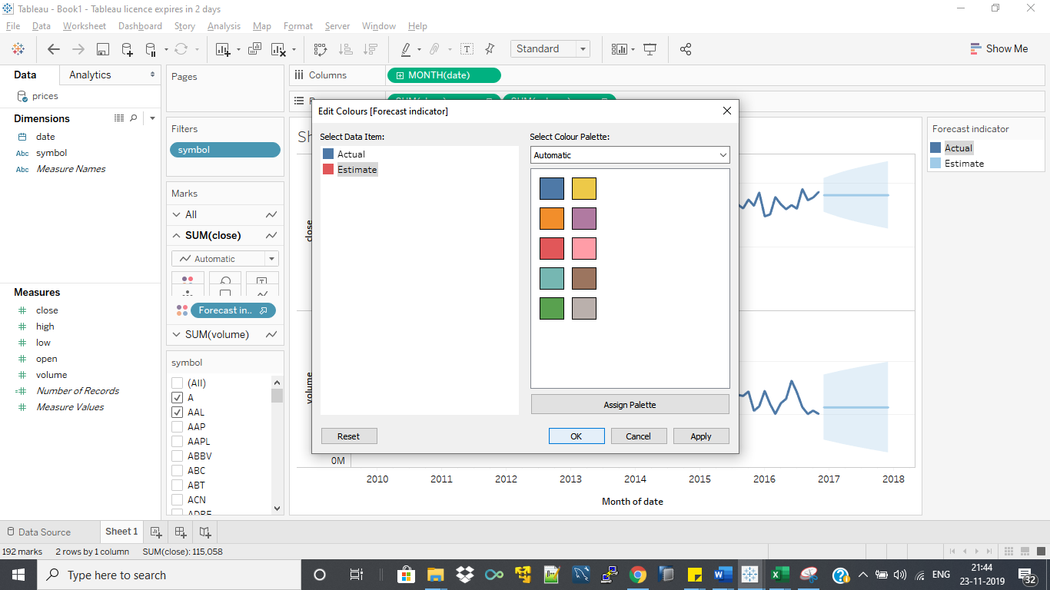

1. Now for customising the forecast we need to right click on forecast graph and follow according to the below image:-

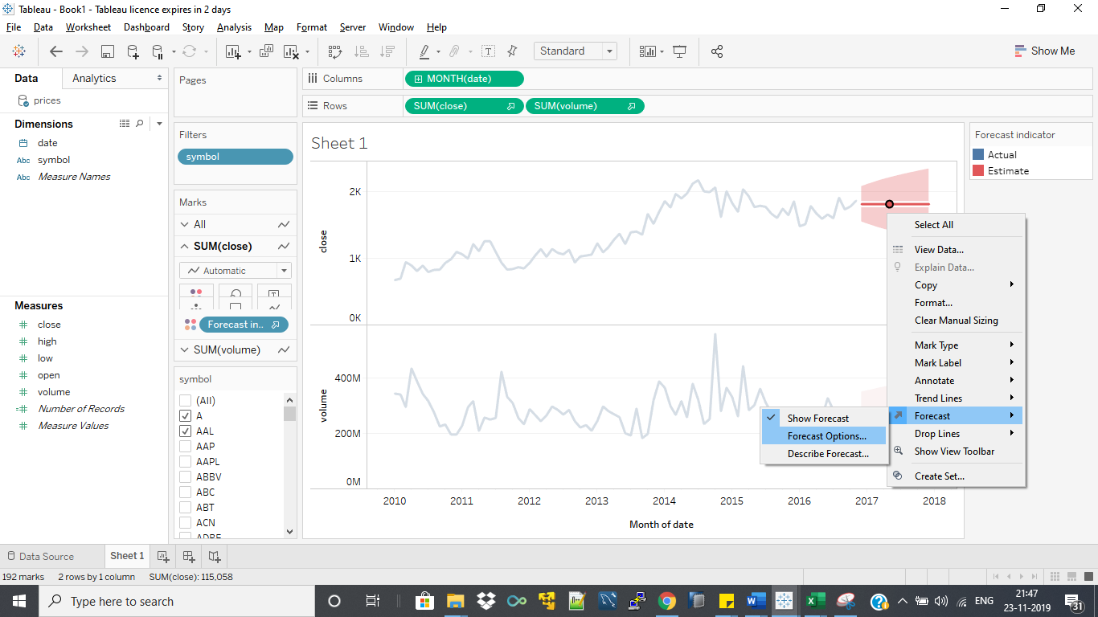

1. After selecting the forecast option we find options as described in below image. We have First option as Forecast length to select the time for which we want to display the forecast. I have selected it as 2 years.

Second option is used for the aggregation and to deselect any records from the actual data. This option is used to deselect any data if it is the result of some natural calamity.

Third option is Forecast model. Automatically tableau select synchronising model. But we can select the model which does not include seasonality and also can customise the model to choose TRENDS and SEASONALITY in ADDITITVE or MULTIPLICATIVE manner. We can also decide the prediction level of our forecasting using the drop down here. I have used 99% for the prediction level and it is shown in graph as spread light pink colour in graph. It shows how much correctly I can predict forecasted value.

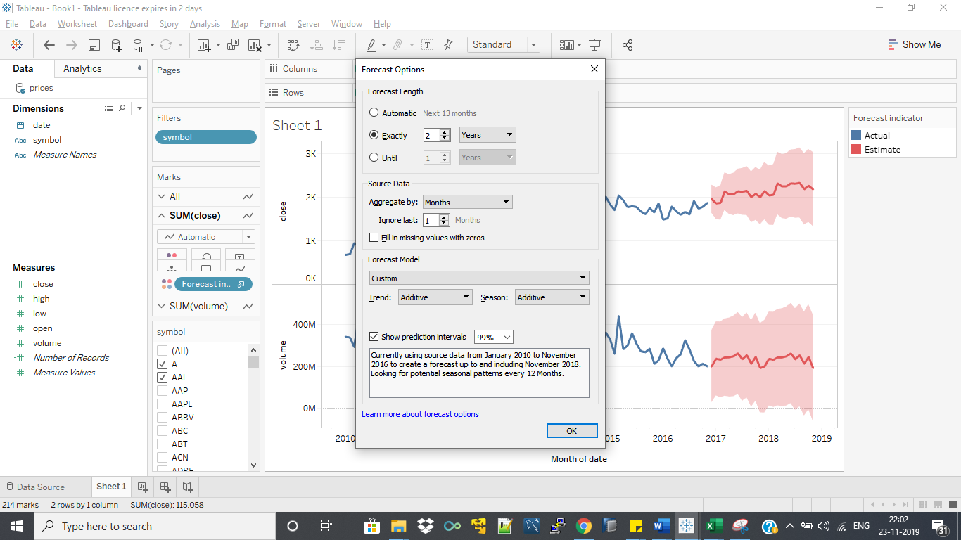

1. We can also describe to know our forecasting using the following clicks :-

